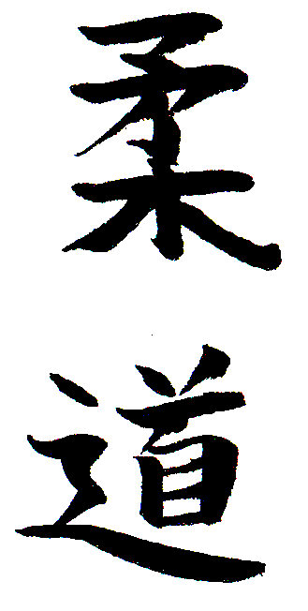
Leinster Open Kyu Championships 2024

Greenhills Community Sports and Leisure Centre, Rear of St Joseph’s Road, Greenhills, Dublin 12 (D12 Y899)

DATE Saturday 13th April 2024

TIME Competition starts at 2.00pm

CHECK-IN Saturday 13th April 2024 1.00pm – 1.30pm

ENTRY FEE €35

CATEGORIES:

Male | Lower Kyu under 81kg | Lower Kyu over 81kg
Male | Middle Kyu under 81kg | Middle Kyu over 81kg
Male | Upper Kyu under 81kg | Upper Kyu over 81kg

Lower Kyu – White & Yellow
Middle Kyu – Orange & Green
Upper Kyu – Blue & Brown

Female | Lower Kyu (white/yellow/orange) | Upper Kyu (green/blue/brown)

NB Please note that event organizers reserve the right to merge/amend categories on the day if numbers are not sufficient or warrant change.

NO ENTRY ON THE DAY

LAST DATE FOR ENTRIES: Monday 8th April 2024.

ENTRIES TO: judoleinster@gmail.com or Leo Gibbons, 11 Brookdale Lawns, Rivervalley, Swords, Co Dublin

Revolut Payment can be made to 0832071065 (please make sure if using this method that players name/DOB/weight category is shown and email entry form to judoleinster@gmail.com).

Cheques/Postal Orders are not accepted.

Leinster Open Kyu Championships 2024

Greenhills Community Sports and Leisure Centre, Rear of St Joseph’s Road, Greenhills, Dublin 12 (D12 Y899)

Entry Form

Name: ………………………………………………………. Club - ………………....

Age: ………………………Grade: ……………………. Membership No:……………

Entry Fee Enclosed………… Federation: …………………………………………………….

Categories Entered:

Please circle the categories you wish to enter.

CATEGORIES:

Male | Lower Kyu under 81kg | Lower Kyu over 81kg
Male | Middle Kyu under 81kg | Middle Kyu over 81kg
Male | Upper Kyu under 81kg | Upper Kyu over 81kg

Lower Kyu – White & Yellow
Middle Kyu – Orange & Green
Upper Kyu – Blue & Brown

Female | Lower Kyu (white/yellow/orange) | Upper Kyu (green/blue/brown)

Competitors Signature: ……………………………………….

COMPETITION:

The Competition will be run in pools & knockout with double repechage.
Minimum entry 4 per category otherwise categories will be amalgamated.

- All Competitors must hold a current membership card with the IJA, NIJF, BJA or from an Association affiliated to the International Judo Federation.
- All female competitors must wear a white tee-shirt underneath their judogi.
- No responsibility for loss or injury will be accepted by Leinster Judo Council or their agents.
- For the weigh-in all players must weigh in wearing Judo Pants & a Tee Shirt– a tolerance of .8kg will be permitted.

